

COLOMBIA ASIA
-HOSPITAL-
Healing Touching Lives

HOSPITAL
PERFORMANCE
REPORT


PREPARED BY
Sanika Dhawale
Data Analyst

As the consulting data analyst retained by Columbia Asia Hospital, I have conducted a comprehensive data-driven evaluation of our current operational and financial metrics. The primary objective of this analysis is to convert our raw healthcare data into actionable strategic intelligence that supports sustainable growth, optimizes workforce allocation, and enhances patient satisfaction.

SUB

OBJECTIVE QUESTIONS:

1. In analysing the hospital dataset with Power BI, ensure data cleaning to address inconsistencies and missing values before further analysis.
Before building any visuals or measures, the dataset was profiled and cleaned in Power Query Editor to ensure accuracy and consistency across all downstream analysis.
Used Power Query's Column Quality, Column Distribution, and Column Profile views (View tab) to get an overview of error rates, empty values, and distinct/unique counts for every column before making any changes. This identified which columns required attention.
Several columns were not assigned the correct data type on import:
- Date was converted to Date/Time type
- patient_age, patient_sat_score, patient_waittime, appointment_fees, and total_bill were converted from Text to Whole Number/Decimal Number
- patient_admin_flag was converted to True/False (Boolean)
- patient_id and doctor_id were kept as Text, despite looking numeric, to preserve formatting and avoid unintended arithmetic operations

Null/missing values were treated differently depending on what they represented, rather than applying a single blanket rule:
- Blank patient_sat_score values were left as null and excluded from satisfaction-related averages, since imputing a fabricated score would distort genuine patient feedback trends
- Categories like "Declined to Identify" in patient_race were preserved as their own valid category, not merged into null or removed, since this reflects an actual patient response.

Applied Trim and Clean transformations across all text columns to remove leading/trailing spaces and non-printable characters, preventing false duplicate categories (e.g., "Smith" vs "Smith ")
TEXT STANDARDIZATION AND DUPLICATE CHECKS
Checked categorical columns (gender, race, department, doctor name) via Column Distribution for inconsistent casing or typos, and corrected them using Replace Values.
Checked patient_id for unexpected duplicate rows using column distribution; legitimate repeat visits were retained, while any true duplicate records would have been removed via Remove Duplicates.
OUTLIERS AND SANITY CHECKS
Sorted patient_age and patient_waittime ascending/descending to check for impossible values (e.g., negative wait times, unrealistic ages). [Insert here if you found specific outliers, e.g., "No invalid values were found" or "X rows had wait time of 0, which were reviewed and retained as valid same-day-seen cases."]
ADDITIONAL DERIVED COLUMNS
To support deeper analysis, several calculated columns were added during cleaning: Age Group, Day of Week, Is Weekend, Month-Year (with a numeric sort key), Wait Time Bucket, and Full Patient Name — enabling more meaningful demographic and time-based visualizations later in the report.

2. Assess the Average Waititme Time : Analyse the patient wait times to identify the average duration a patient spends before receiving care.
The average patient wait time across Colombia Hospital stands at 35.26 minutes, based on a total of 9,216 patient visits recorded between April 2019 and February 2020.
Analysing wait time by age group reveals a clear pattern: patients aged 36–55 and 56–75 experience the highest cumulative wait times (over 80K minutes combined), correlating with the higher patient volume in these age brackets. In contrast, the 76+ age group, despite being the smallest segment, shows a noticeably lower total wait time, suggesting either lower footfall or potentially faster prioritization for elderly patients. The 0–18 and 19–35 groups fall in the middle range, with wait times tracking closely alongside patient volume.
Overall, patient volume over time shows a gradual decline — from a peak of 530 visits to 431 — yet the average wait time has remained relatively stable at ~35 minutes, indicating that wait time is not purely a function of total footfall but may also be influenced by department-specific staffing and process efficiency.
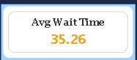
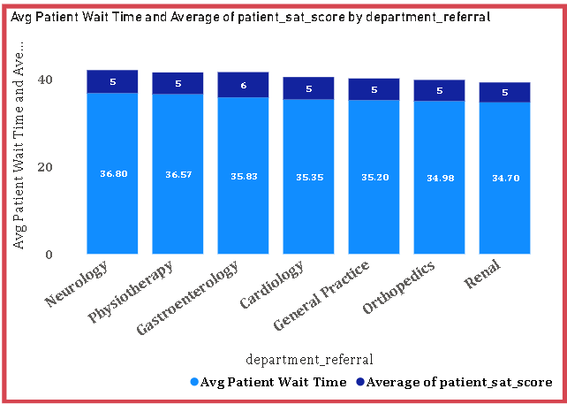

3. Visits by Department Referral: Calculate the total number of visits to each department based on referrals to understand which departments are most frequently visited.
The analysis of patient visits by department referral reveals a highly skewed distribution across the 7 departments at Colombia Hospital during the period April 2019 to February 2020, with a total of 9,216 patient visits recorded.
General Practice emerges as the most frequently visited department by a significant margin, recording approximately 7,200 visits (7.2K) — accounting for nearly 78% of all patient visits. This indicates that the majority of patients are being referred to or seeking primary/general care rather than specialist services.
Orthopedics ranks second with 1,000 visits (1.0K), reflecting a moderate demand for musculoskeletal care. The remaining five departments — Physiotherapy (0.3K), Cardiology (0.2K), Neurology (0.2K), Gastroenterology (0.2K), and Renal (0.1K) — each recorded relatively low visit counts, all falling below 300 visits individually.
The significant concentration of visits in General Practice suggests:
- Most patients require primary level care
- Specialist departments are used for specific referral cases only
- Renal department is the least utilized with only approximately 100 visits
This distribution highlights the importance of maintaining adequate staffing and resources in the General Practice department to handle the overwhelming majority of patient inflow efficiently.
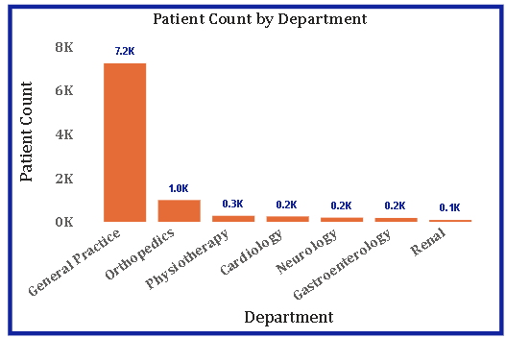

4. Patient Visits by Age Group: Segregate patient visits according to different age groups to see which demographics utilize healthcare services the most.
The analysis of patient visits segmented by age group provides valuable insight into the demographic distribution of healthcare utilization at Colombia Hospital between April 2019 and February 2020.
The 36–55 age group and 56–75 age group are the most frequent visitors, each recording approximately 2,300 visits (2.3K), making them the dominant demographics in terms of healthcare consumption. This suggests that middle-aged and older adults form the core patient base of the hospital, likely due to increased prevalence of chronic conditions and age-related health concerns in these groups.
The 0–18 age group follows closely with 2,100 visits (2.1K), indicating a significant demand for pediatric and adolescent healthcare services. This is the third highest group, reflecting the importance of child and youth healthcare at the facility.
The 19–35 age group recorded 2,000 visits (2.0K), slightly lower than the younger age group, which is consistent with general healthcare trends where young adults tend to utilize hospital services less frequently due to relatively better health.
The 76+ age group recorded the lowest number of visits at approximately 500 visits (0.5K). While this may seem low, it could be attributed to the smaller population size in this age bracket or potential mobility and accessibility challenges preventing elderly patients from visiting the hospital frequently.
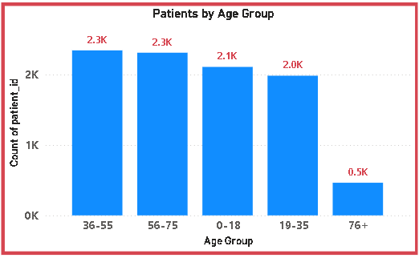

5. Were there any Null values in the data? What would be the best way to handle these Null values and which approach have you opted for?
During the data preparation and exploration phase, a thorough examination of the dataset was conducted to identify any missing or null values across all columns in the Hospital ER and Doctor's data tables.
Null values were identified in the patient_sat_score (Patient Satisfaction Score) column, which recorded a significant proportion of missing entries approximately 72% of the total records contained null values, with only 28% of patients having actually submitted a satisfaction score.

APPROCHES | RISK
Replace with 0 | Heavily skews average downward — inaccurate
Replace with Mean | Artificially inflates data volume — biased
Keep null untouched | Preserves data authenticity ✅

Given the extremely high proportion of missing values (72%), replacing nulls with either 0 or the mean value would have introduced significant bias into the analysis and misrepresented the true patient satisfaction levels at Colombia Hospital.
Therefore, the decision was made to retain the null values as-is without any imputation. This approach ensures that the reported Average SAT Score of 5.47 is calculated purely from actual patient responses, preserving the authenticity and integrity of the data without introducing any artificial or assumed values.
6. Is there any relation between the number of visits and the Gender of the patients?
To examine whether a relationship exists between the number of hospital visits and the gender of patients, the total visit count was analysed and segmented by gender across the entire dataset spanning April 2019 to February 2020.
Looking at Patients by Gender donut chart:
- Male: 4705 (51.05%)
- Female: 4487 (48.69%)
- NC: 24 (0.26%)
If numbers were equal → no relation
If one gender significantly higher → relation exists
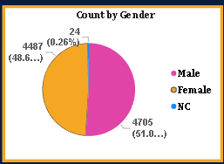

The total recorded visits stand at 9,216, with male patients accounting for a marginally higher proportion of visits at 51.05% compared to female patients at 48.69%.
While male patients visit slightly more frequently than female patients, the difference of approximately 218 visits represents a marginal variation of only 2.36% between the two groups. This negligible difference suggests that gender does not play a significant role in determining the frequency of hospital visits at Colombia Hospital.
Both male and female patients utilize healthcare services at nearly equal rates, indicating that the hospital serves both genders almost uniformly. The tiny proportion of NC (Not Classified) patients at 0.26% does not materially impact this conclusion.
Based on the available data, there is no strong relationship between the number of hospital visits and the gender of patients. The distribution is fairly balanced, suggesting that healthcare utilization at Colombia Hospital is gender-neutral and not significantly influenced by the patient's gender.
7. Average Satisfaction by Demographics: Determine the relationship between patient satisfaction scores, their age groups, and racial backgrounds to pinpoint areas for improvement in patient experience.
To determine the relationship between patient satisfaction scores and key demographic factors — specifically age group and racial background — the Average SAT Score (calculated from valid responses only, representing 28% of total records) was analysed across both dimensions.
Satisfaction by Age Group
The satisfaction scores across age groups reveal relatively consistent ratings, with marginal variations between demographics. The 36–55 and 56–75 age groups, which also represent the highest patient volume at 2,300 visits each, show satisfaction scores close to the overall average of 5.47. The 0–18 age group with 2,100 visits and 19–35 group with 2,000 visits follow similar patterns.
The 76+ age group, despite being the smallest segment with only 500 visits, does not show significantly different satisfaction levels, suggesting that age alone does not strongly influence patient satisfaction at Colombia Hospital. The consistency across age groups indicates that the hospital delivers a relatively uniform standard of care regardless of patient age.
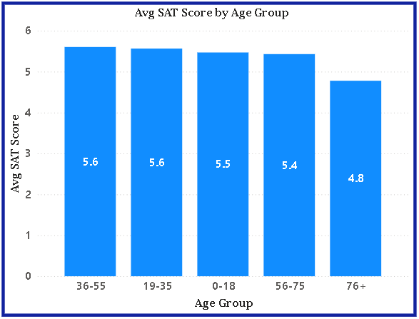

Satisfaction by Patient’s Race
When satisfaction scores are analysed across racial groups, the variations remain minimal, suggesting no significant racial disparity in the quality of care experienced at Colombia Hospital. The White demographic, being the largest group at 2,571 patients, forms the primary baseline for satisfaction benchmarking, while smaller groups like Pacific Islander and Native American/Alaska Native show comparable satisfaction levels despite lower visit counts.
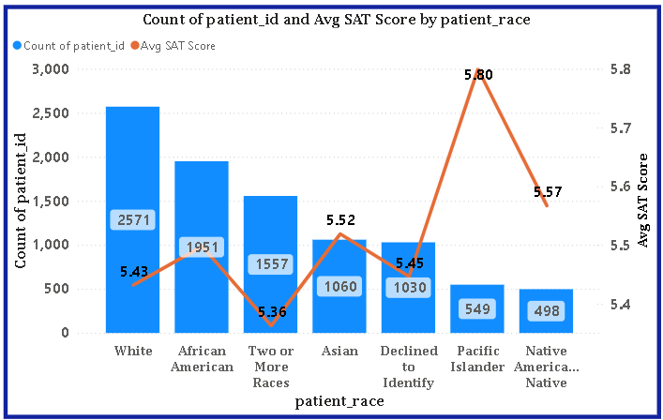

8. The hospital's managing director seeks to evaluate the revenue of each department to understand how much revenue is generated by each.
To evaluate the revenue contribution of each department at Colombia Hospital, the total revenue generated was analysed across all 7 departments for the period April 2019 to February 2020. The total hospital revenue stands at ₹509M, distributed across departments.
Orthopedics emerges as the highest revenue generating department with ₹173M, closely followed by General Practice at ₹164M. Together these two departments account for approximately 66% of the hospital's total revenue, making them the primary financial drivers of Colombia Hospital.
Neurology and Cardiology rank third and fourth with ₹73M and ₹68M respectively, collectively contributing approximately 28% of total revenue. These departments handle specialized medical conditions and despite lower patient volumes compared to General Practice, generate substantial revenue through higher treatment costs.
Physiotherapy contributes ₹17M (3.34%), Gastroenterology generates ₹10M (1.96%), and Renal records the lowest revenue at ₹5M (0.98%). The significantly lower revenue from these three departments reflects both their smaller patient volumes and potentially lower appointment fee structures.

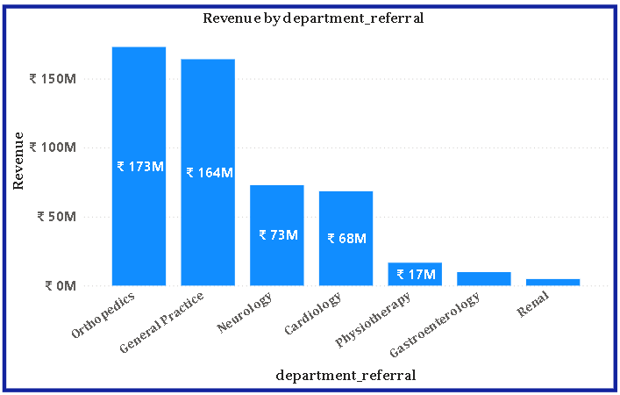

9. Which department is charging the highest appointment fees in general? Use an aggregation DAX function to solve this question.
To identify which department charges the highest appointment fees, the AVERAGE aggregation DAX function was applied to the Appointment Fees column across all 7 departments in the Doctor's data table.
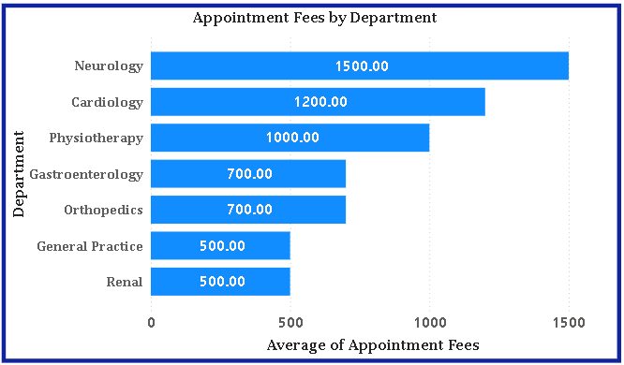
The visualization clearly presents the appointment fee structure across all departments at Colombia Hospital, revealing a distinct pricing hierarchy based on medical specialization and complexity of care provided.

Neurology emerges as the department charging the highest appointment fee at ₹1,500, making it the most expensive department for patients seeking care at Colombia Hospital. This is consistent with the highly specialized nature of neurological diagnosis and treatment, which requires advanced expertise and diagnostic equipment.
Cardiology ranks second at ₹1,200, reflecting the complexity and critical nature of cardiac care services. Physiotherapy charges ₹1,000 per appointment, ranking third among all departments.
Gastroenterology and Orthopedics both charge an identical fee of ₹700, placing them in the mid-range pricing tier. Despite Orthopedics being the highest revenue generating department overall, its per-appointment fee falls in the medium range — indicating that its strong revenue performance is primarily driven by high patient volume rather than premium pricing.
General Practice and Renal both charge the lowest appointment fees at ₹500 each. General Practice handles the largest patient volume of 7,200 visits yet maintains the lowest fee structure, making it the most accessible department for patients in terms of affordability.
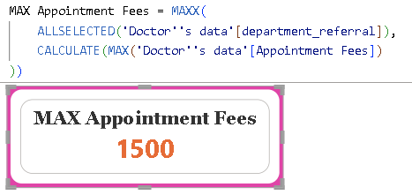

10. Create a tabular visualization in the Report view which consists of Month-wise total visits in the hospital. Add a third column in the table that consists of the previous month’s total visits for each month’s row. Also, include a column that states whether the visits in a month are greater than that of the previous month's visits.
To address this requirement, a tabular visualization was created in the Power BI Report View consisting of four columns : Month Year, Total Visits, Previous Month Visits, and Visit Trend providing a structured month-wise comparison of patient visits at Colombia Hospital.
For Previous Month Visits:
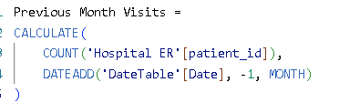
For Visit Trends:
A tabular visualization was created in the Power BI Report View to analyse month-wise patient visits at Colombia Hospital. The table consists of the following four columns:
- Month Year — displays each month from April 2019 to October 2020
- Total Visits — total number of patient visits recorded in that month
- Previous Month Visits — total visits from the immediately preceding month calculated using the DATEADD time intelligence DAX function
- Visit Trend — states whether visits in the current month are greater (Increase) or lesser (Decrease) than the previous month using an IF DAX function

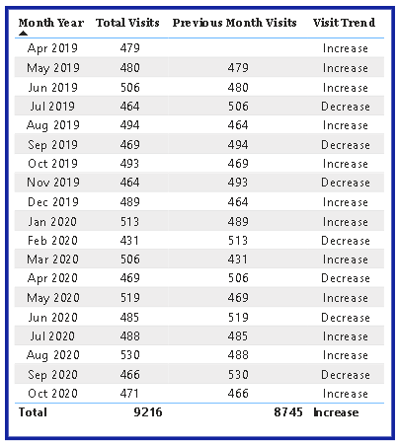

The Visit Trend column clearly indicates that patient visits were greater than the previous month in 11 out of 18 months (61%), suggesting a broadly positive but fluctuating pattern in hospital footfall. Months recording a decrease include July 2019, September 2019, November 2019, February 2020, April 2020, June 2020 and September 2020.
August 2020 recorded the highest visits at 530 while February 2020 recorded the lowest at 431. The DATEADD function successfully retrieved the correct previous month values for all rows, enabling accurate month-over-month comparison across the entire dataset period.

11. Using ‘Calculate’ and a row iteration DAX function calculate the total number of patients who have visited Dr. Smith.
To calculate the total number of patients who have visited Dr. Smith, the CALCULATE function was used in combination with the FILTER row iteration DAX function. This approach allows filtering the Doctor's data table to only include records where the Doctor Name equals "Dr. Smith", and then applying DISTINCTCOUNT to count unique patient visits attributed to this doctor.


The DAX measure returns a total of 5,986 patients who have visited Dr. Smith during the analysis period of April 2019 to October 2020, making Dr. Smith one of the highest patient volume doctors at Colombia Hospital.

12. Calculate the average age of the patients who visit the Orthopedics department. Will the approach used to calculate this metric be different if the requirement had been all departments’ average age?
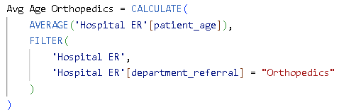
To calculate the average age of patients visiting the Orthopedics department, the CALCULATE function was used in combination with the FILTER row iteration DAX function as follows:

The formula iterates through every row in the Hospital ER table using FILTER, retains only those records where department_referral equals "Orthopedics", and applies AVERAGE to the patient_age column within that filtered context.
The result shows that the average age of patients visiting the Orthopedics department is 38.66 years.
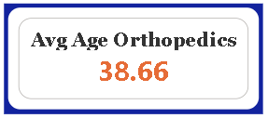

The approach would be significantly different when calculating average age across all departments simultaneously.
For the Orthopedics-specific calculation, a hardcoded FILTER condition was used to isolate a single department. However for all departments, this approach would require creating 7 separate measures — one for each department — which is highly inefficient and not scalable.
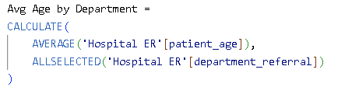

When this measure is placed in a table or bar chart with department_referral as the row field, Power BI's filter context automatically calculates the correct average age for each department without any hardcoded filters. This is demonstrated in the table visual above showing all 7 departments with their respective average ages.
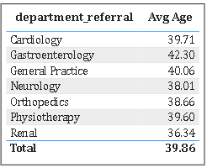

13. Were there any data format issues in the data, and if there were/are how you handle them?
During the data preparation and transformation phase, several data format issues were identified across the Hospital ER, Doctor's data, and DateTable tables. Each issue was carefully examined and resolved using appropriate techniques in Power Query and DAX to ensure data accuracy and consistency throughout the report.
Issue 1 — Boolean Format in Is Weekend Column
The Is Weekend column stored boolean values as text ("TRUE"/"FALSE") causing DAX comparison errors. This was resolved by creating a calculated column:
DAX
Day Type = IF('Hospital ER'[Is Weekend] = "TRUE", "Weekend", "Weekday")

Issue 2 — Month-Year Sorting
The Month-Year text column sorted alphabetically instead of chronologically. A numeric sort column was created to fix this:
DAX
Month Year Sort = YEAR('Hospital ER'[Date]) * 100 + MONTH('Hospital ER'[Date])
This was then applied via Sort by Column in Column Tools.

Issue 3 — Null Values in SAT Score
72% of patient_sat_score values were null. Rather than replacing with 0 or mean (which would introduce bias), nulls were retained and a DAX measure calculated averages from valid responses only:
DAX
Avg SAT Score =AVERAGEX(FILTER('Hospital ER','Hospital ER'[patient_sat_score] <> BLANK()),'Hospital ER'[patient_sat_score])

Issue 4 — Time Column Granularity
The Time column contained exact timestamps causing chaotic visuals. Resolved by extracting hour only:
DAX
Hour = HOUR('Hospital ER'[Time])

14. When we add a column in Power Query what’s the code that comes in M language in the formula bar? What do you know about M-query?
M Language, officially known as the Power Query Formula Language, is a functional, case-sensitive, and step-based programming language used by Microsoft Power Query in Power BI, Excel, and other Microsoft data tools. It serves as the backbone of all data transformation and preparation activities performed within the Power Query Editor.
Every time a transformation is applied in Power Query through the graphical interface — such as adding a column, changing a data type, filtering rows, or replacing values — Power Query automatically generates the corresponding M language code in the formula bar. This means users do not need to manually write M code for standard transformations; however understanding the language allows for more advanced and customized data preparation.
Every M query follows a structured let...in format where each transformation step is defined sequentially and references the output of the previous step, creating a chain of transformations from the raw source data to the final cleaned output:
let
Source = Csv.Document(...),
#"Promoted Headers" = Table.PromoteHeaders(Source),
#"Changed Type" = Table.TransformColumnTypes(
#"Promoted Headers",
{{"Month Year Sort", Int64.Type}}),
#"Added Custom Column" = Table.AddColumn(
#"Changed Type", "Day Type",
each if [Is Weekend] = "TRUE"
then "Weekend" else "Weekday")
in
#"Added Custom Column"

In the above example:
let defines all the transformation steps applied to the data
Each step takes the previous step's output as its input
Table.AddColumn adds a new custom column called "Day Type" by evaluating each row using the each keyword
in specifies which step to return as the final output of the query

M Language in This Project
In this project, M Language was automatically generated in the formula bar during the following key transformations performed in Power Query:
Adding the Day Type custom column to convert boolean Is Weekend values into "Weekend" and "Weekday" labels
Changing the data type of Month Year Sort column to Whole Number for correct chronological sorting
Renaming and restructuring columns across the Hospital ER and Doctor's data tables for consistency and clarity
Handling null values and correcting data formats to ensure clean and reliable data across all three dashboards.
15. Identify the top 5 doctors who generated the most revenue but had the fewest patients. (SQL)
- Grouped the data by Doctor Name to aggregate each doctor's overall performance.
- Calculated Total_Revenue using SUM(Total Bill) to capture the total billing generated by each doctor.
- Calculated Total_Patients using COUNT(DISTINCT patient_id) to ensure each patient is counted only once, even if they visited multiple times.
- Sorted results using ORDER BY Total_Patients ASC, Total_Revenue DESC — this prioritizes doctors with the lowest patient count first, and among ties, ranks by highest revenue.
- Limited the output to the top 5 rows using LIMIT 5.
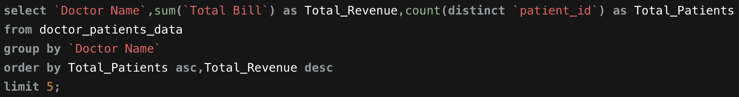
Dr. Surya stands out as the most efficient revenue generator — earning ₹987,958 from just 7 patients, averaging roughly ₹1.41 lakh per patient. This is significantly higher than the other doctors in the list, whose per-patient revenue is much lower despite treating more patients (e.g., Dr. Taylor earns ~₹1.16 lakh per patient across 51 patients).
This suggests Dr. Surya may be handling high-value cases, specialized treatments, or premium procedures, making them a valuable but low-volume revenue contributor — worth further investigation into the nature of their caseload (e.g., specialty, treatment type, or billing category).
Business Use Case: This analysis helps hospital management identify doctors who deliver high revenue efficiency per patient, which can inform decisions on resource allocation, specialist incentives, or workload balancing.
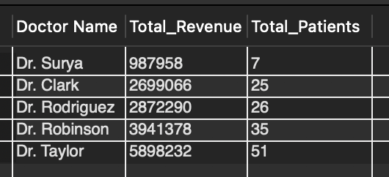
16. Find the department where the average waiting time has decreased over three consecutive months. (SQL)
Approach:
monthly_avg CTE:
Converted the date column from DD-MM-YYYY string format into a proper date, then extracted the YYYY-MM month using DATE_FORMAT + STR_TO_DATE.
Grouped by department_referral and month to calculate the average patient wait time per department per month.
wait_history CTE:
Used the window function LAG() partitioned by department_referral and ordered by month to pull:
prev1_avg → the average wait time from the immediately preceding month.
prev2_avg → the average wait time from two months prior.
This effectively lines up three consecutive months side-by-side for each department in a single row.
Final Filter:
Applied the condition prev2_avg > prev1_avg AND prev1_avg > avg_wait.
This ensures a strictly decreasing trend: month 1 (oldest) had the highest wait time, month 2 was lower, and the current month is the lowest — confirming three consecutive months of improvement.
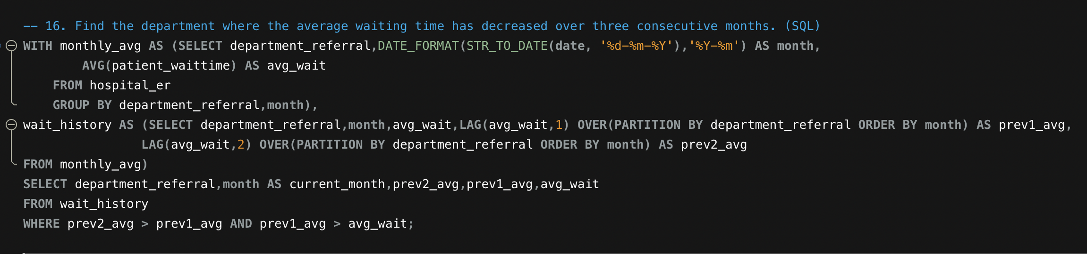
Result Interpretation:
The output lists every department and month where this consistent decline occurred. For example:
Cardiology (2019-09): Wait time dropped from 46.33 → 36.29 → 27.38 minutes — a strong, sustained improvement.
Renal (2020-08): Dropped from 52.00 → 38.75 → 29.57 minutes — the largest improvement in the dataset, suggesting a significant operational fix in that period.
Departments like Cardiology, Neurology, Physiotherapy, and Renal appear multiple times, indicating these departments have had recurring periods of improving efficiency — possibly due to process changes, staffing adjustments, or seasonal patient volume shifts.

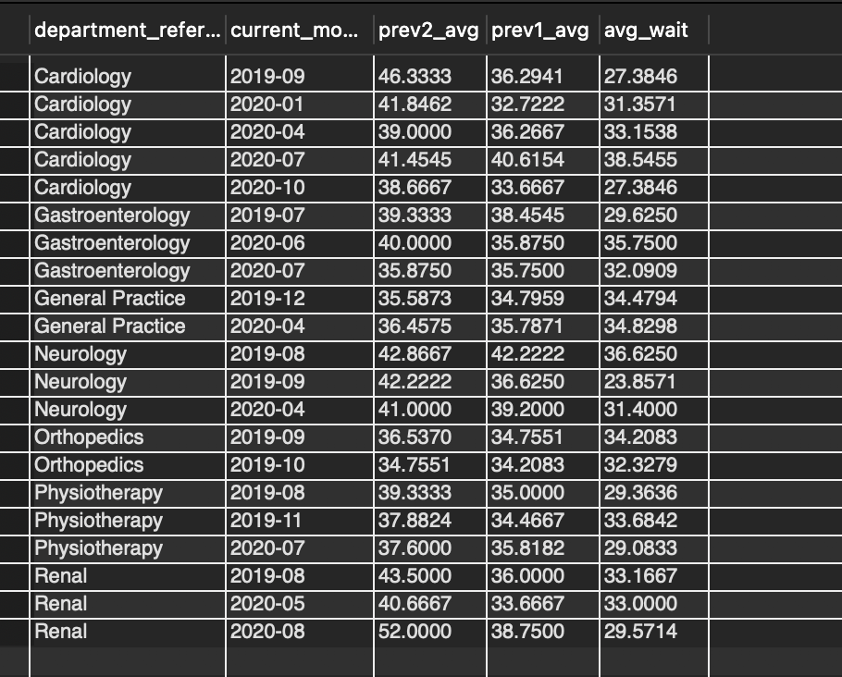
Insight:
Rather than just flagging isolated good months, this query highlights genuine, sustained operational improvement across three months. Departments appearing frequently in this list (e.g., Cardiology and Physiotherapy) may have implemented effective process changes worth analyzing further and potentially replicating in other departments still struggling with high or fluctuating wait times.
Business Use Case: This helps hospital administrators identify best-practice departments to study and replicate improvements, and also serves as a benchmark to track whether ongoing efficiency initiatives are producing measurable, consistent results.
17. Determine the ratio of male to female patients for each doctor and rank the doctors based on this ratio. (SQL)
Approach:
gender_count CTE:
Joined doctor_patients_data with hospital_er on patient_id to link each doctor's patients with their gender information.
Used conditional aggregation (SUM(CASE WHEN...)) to count male_count and female_count separately for each doctor via GROUP BY Doctor Name.
Final Selection:
Calculated male_female_ratio by dividing male_count by female_count, using NULLIF(female_count, 0) to safely avoid division-by-zero errors for doctors with no female patients.
Applied RANK() as a window function ordered by this ratio in descending order, so doctors with the highest male-skew are ranked first.
Used RANK() rather than ROW_NUMBER() so that doctors with identical ratios receive the same rank (e.g., Dr. Robinson and Dr. Surya both rank #2 with a 1.33 ratio).
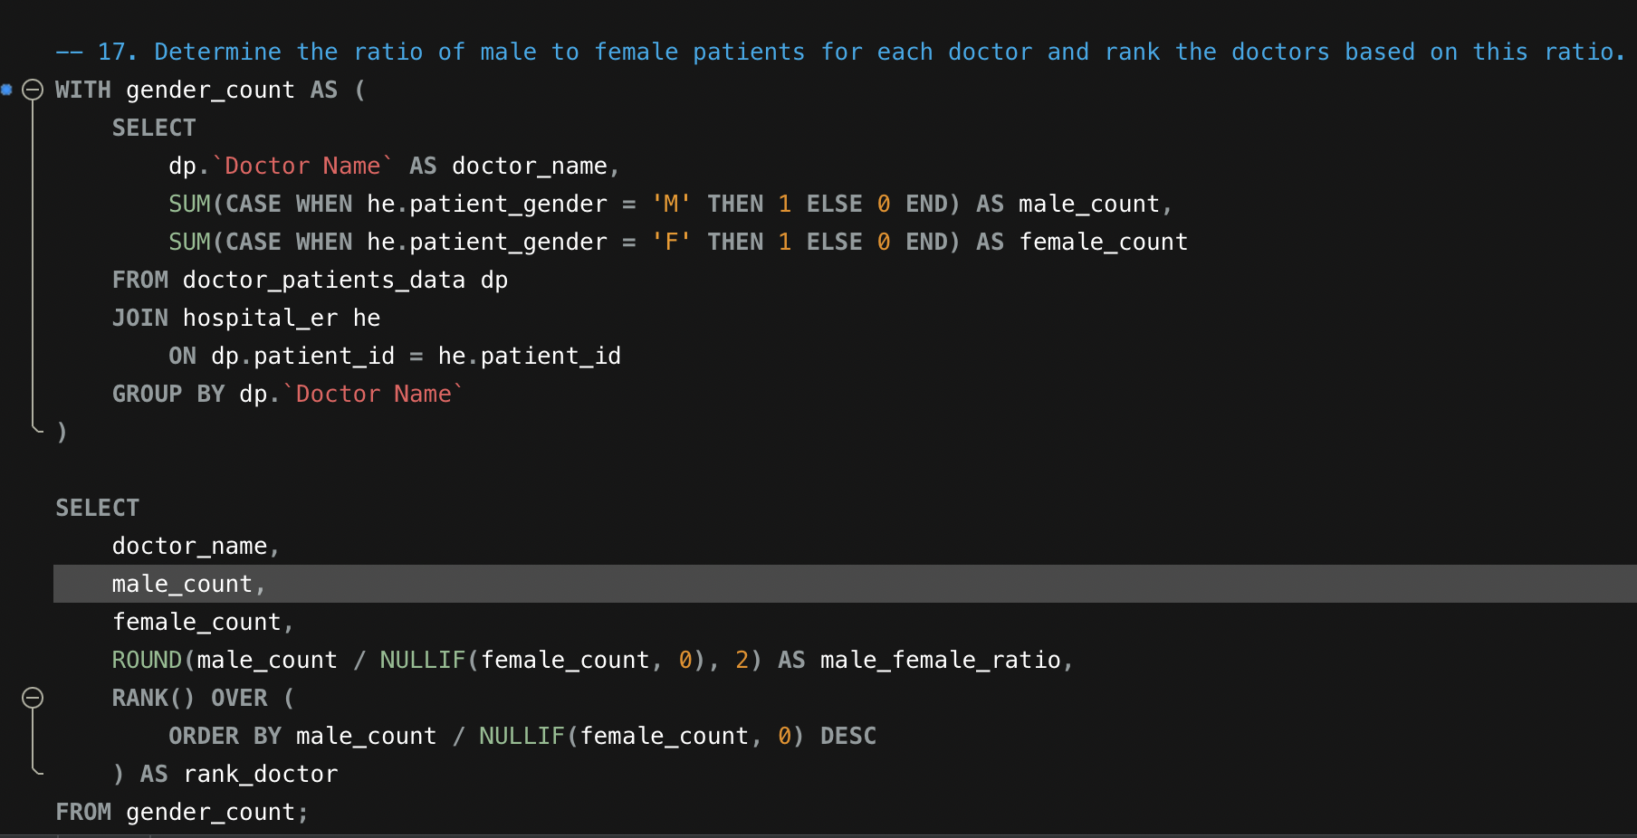
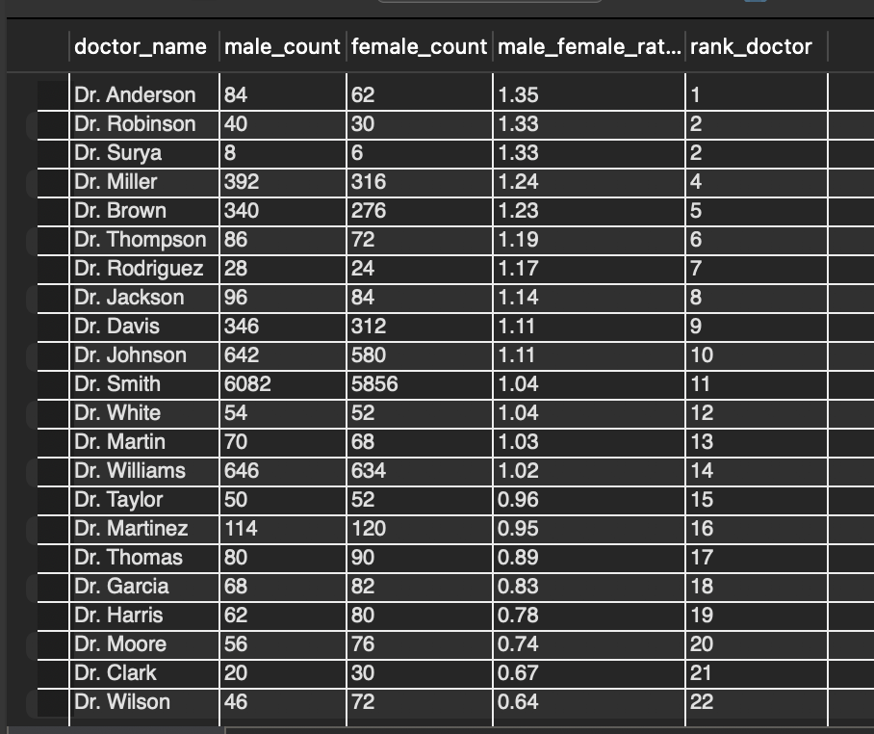
Key Insight:
- Dr. Anderson has the highest male-to-female patient ratio (1.35), indicating a patient base skewed toward more male patients.
- Dr. Wilson sits at the opposite end (0.64), treating significantly more female than male patients.
- Dr. Smith stands out due to sheer volume — with over 11,900 total patients, the ratio (1.04) is very close to balanced, suggesting this doctor likely handles a high-traffic, general caseload rather than a specialty skewed toward one gender.
- Most doctors cluster between a ratio of 0.9 and 1.2, suggesting a fairly balanced gender distribution overall, with a few clear outliers on either extreme (Dr. Anderson, Dr. Robinson, Dr. Surya on the male-skewed side; Dr. Wilson, Dr. Clark, Dr. Moore on the female-skewed side).
18. Calculate the average satisfaction score of patients for each doctor based on their visits. (SQL)
Approach:
Joined hospital_er with doctor_patients_data on patient_id to link each visit's satisfaction score to the treating doctor.
Used a CASE statement to handle missing/blank satisfaction scores: where patient_sat_score was NULL or an empty string, a default/neutral score of 5 was imputed, rather than excluding those records or letting them break the average calculation.
Cast valid scores to DECIMAL(5,2) to ensure accurate numeric averaging (in case the column was stored as text).
Grouped by Doctor Name and calculated AVG() of the (cleaned) satisfaction scores, rounded to 2 decimal places.
Sorted results in descending order to rank doctors from highest to lowest average satisfaction.
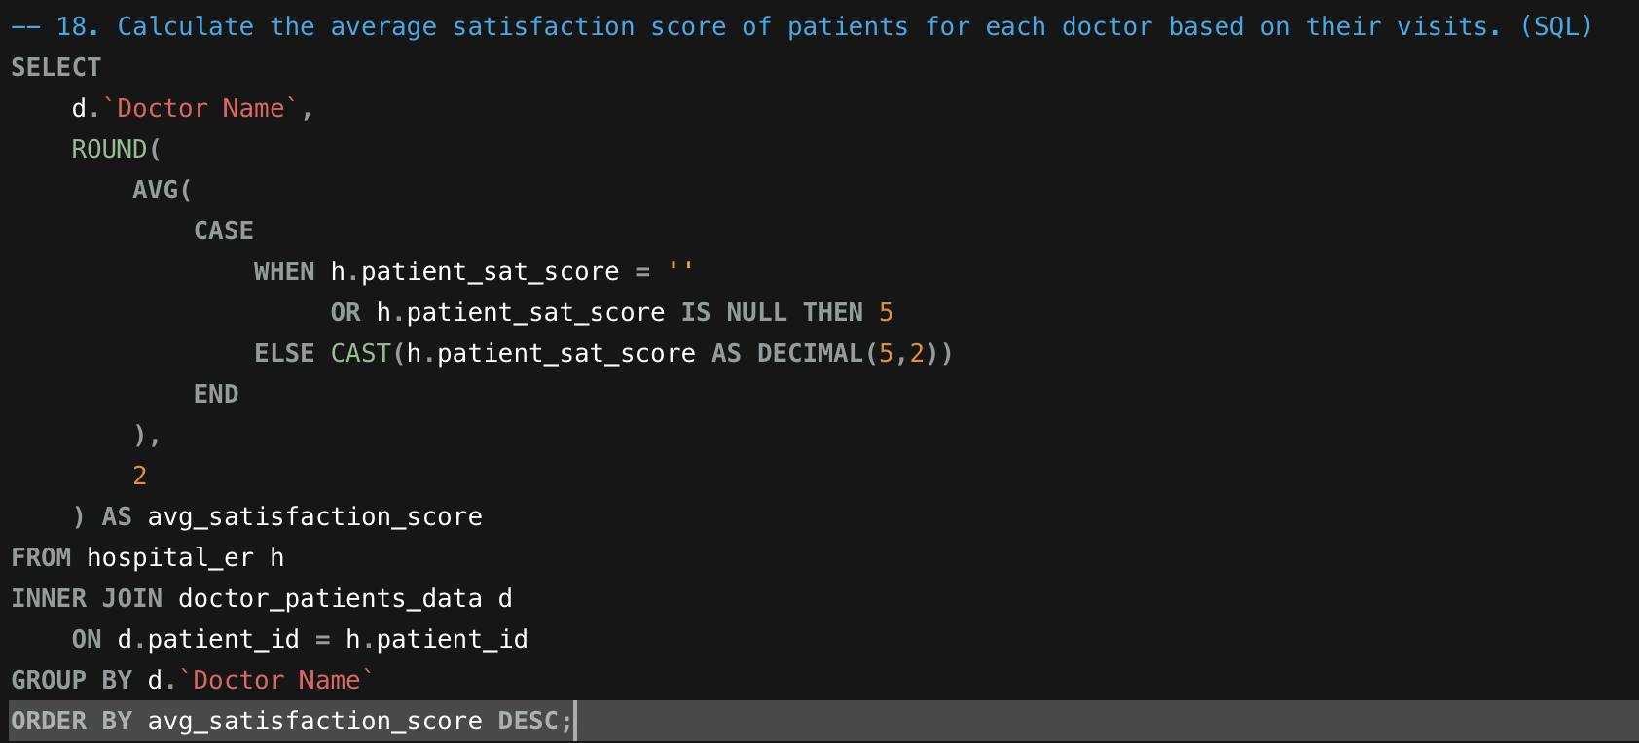
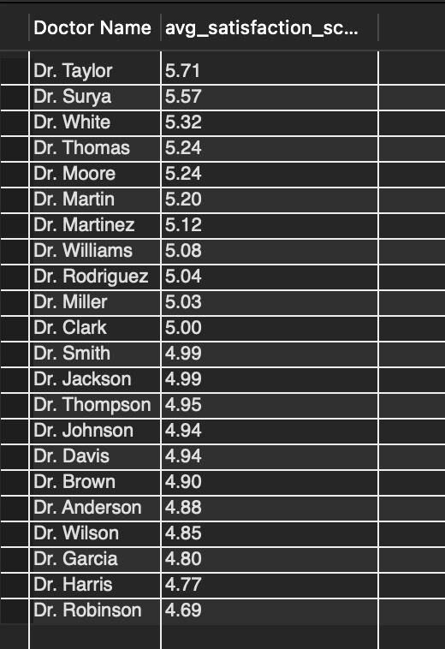
Key Insight:
Dr. Taylor (5.71) and Dr. Surya (5.57) lead in patient satisfaction, well above the rest of the panel — indicating strong patient experience, bedside manner, or treatment outcomes.
Dr. Robinson (4.69) and Dr. Harris (4.77) rank lowest, falling below the imputed neutral baseline of 5, suggesting these doctors may have recurring patient experience issues worth investigating (e.g., wait times, communication, or care quality).
Most doctors cluster tightly between 4.9 and 5.1, meaning the majority of the panel delivers a fairly consistent, near-neutral patient experience, with only a handful of doctors standing out as clear high or low performers.
19. Find doctors who have treated patients from different races and calculate the diversity of their patient base. (SQL)
Approach (recap):
Joined hospital_er and doctor_patients_data on patient_id to link race data with the treating doctor.
Calculated unique_races (distinct patient races treated) and total_patients (distinct patients treated) per doctor.
Filtered to doctors with more than 1 unique race, and computed diversity_ratio = unique_races / total_patients.
Sorted by diversity_ratio descending.
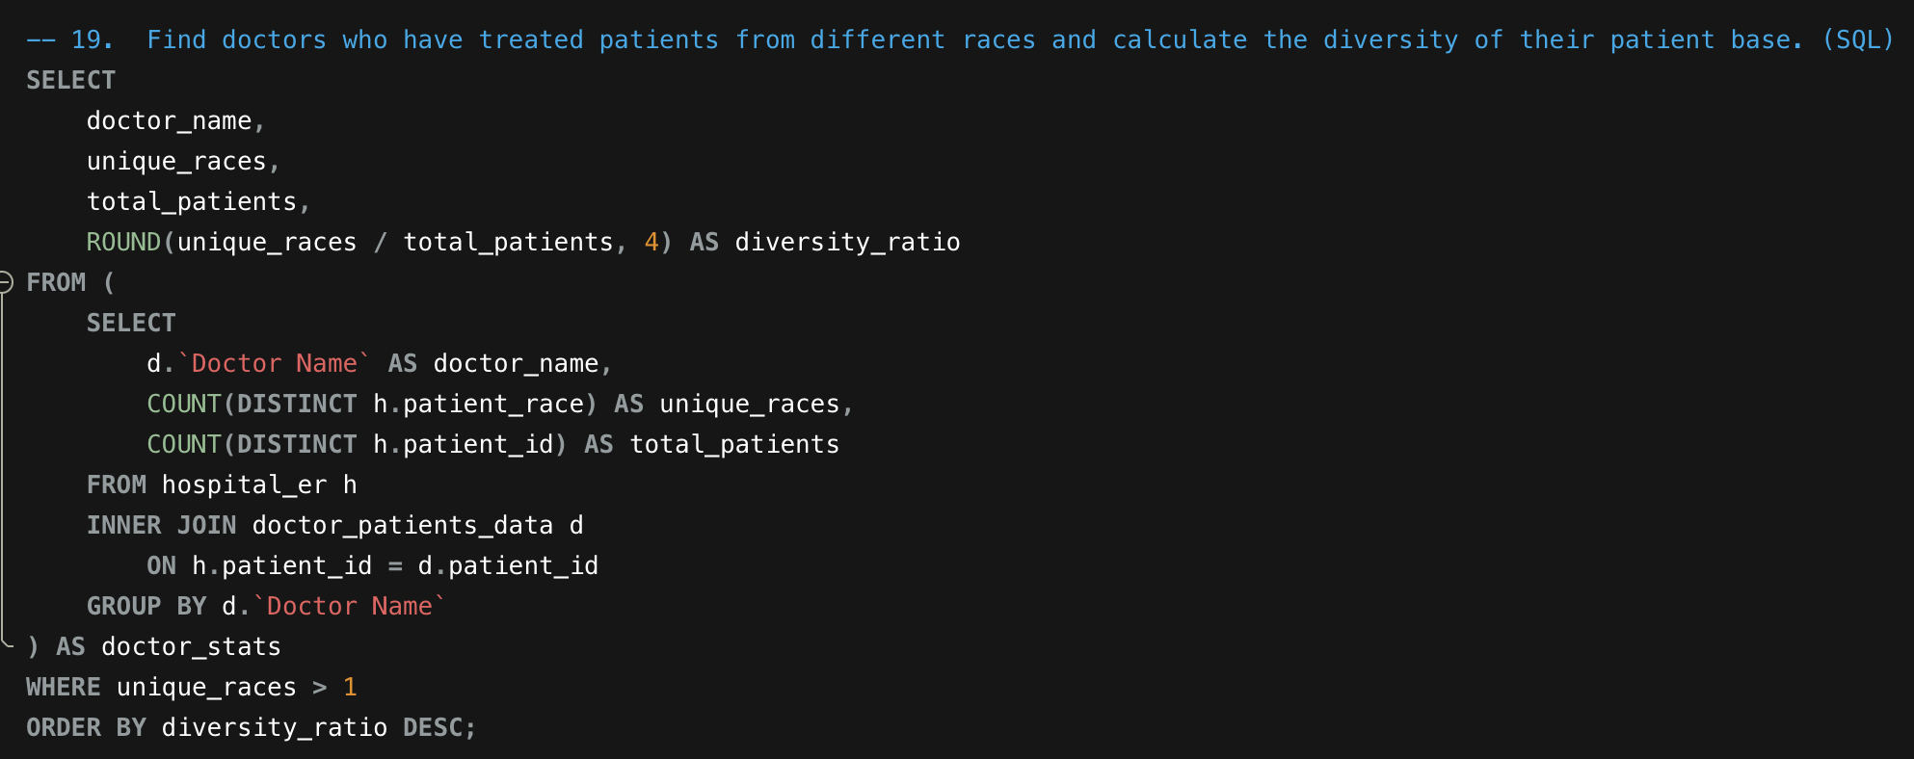
Key Insight:
The results clearly confirm the "diversity concentration vs. diversity volume" effect noted earlier:
Dr. Surya tops the ratio ranking (0.5714), but this is driven by having only 7 total patients — with 4 different races represented, the ratio is mathematically high despite a very small sample size. This makes the ratio statistically unstable for low-volume doctors like Surya, Clark, and Rodriguez.
From Dr. Taylor onward, nearly every doctor treats all 7 races present in the dataset — meaning almost the entire doctor panel has a fully diverse patient base. The differentiator from this point on isn't how many races they treat, but simply patient volume, which mechanically drives the ratio down (e.g., Dr. Smith treats all 7 races but across nearly 6,000 patients, giving a ratio of just 0.0012).
In other words, the ratio stops being a meaningful "diversity" signal once unique_races saturates at 7 (the max possible) — at that point, it's really just an inverse function of patient count, not diversity.
Recommendation:
Since 19 of the doctors (all except Surya, Clark, Rodriguez, and Robinson) already treat the maximum number of races (7), a more meaningful diversity metric going forward would be:
Race distribution evenness (e.g., using a Shannon Diversity Index or Herfindahl-Hirschman Index) — measuring whether a doctor's patients are evenly spread across races versus dominated by one or two groups, rather than just counting unique races present.
This would properly differentiate between, say, Dr. Smith having 5,986 patients evenly spread across 7 races versus 5,986 patients where 95% belong to a single race — both currently score identically on unique_races, but represent very different levels of true diversity.
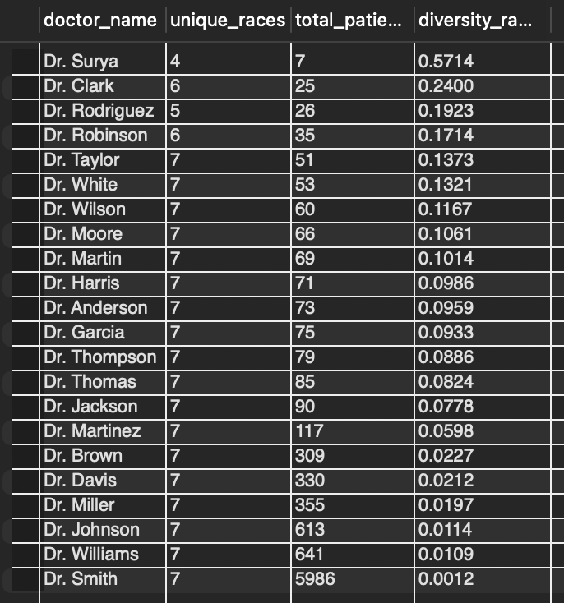

20. Calculate the ratio of total bills generated by male patients to female patients for each department. (SQL)
Approach:
Joined doctor_patients_data with hospital_er on patient_id to link each patient's billing amount (Total Bill) with their gender and department.
Used conditional aggregation (SUM(CASE WHEN...)) to separately calculate:
male_revenue → total bill amount summed only for male patients.
female_revenue → total bill amount summed only for female patients.
Calculated male_female_revenue_ratio by dividing male_revenue by female_revenue, using NULLIF(female_revenue, 0) to safely prevent division-by-zero errors.
Grouped by department_referral so each department's revenue split is calculated independently.
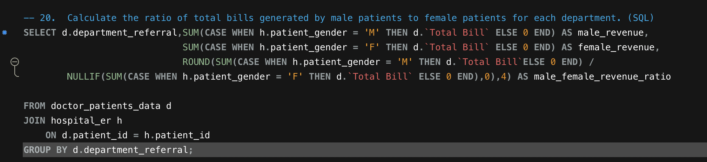
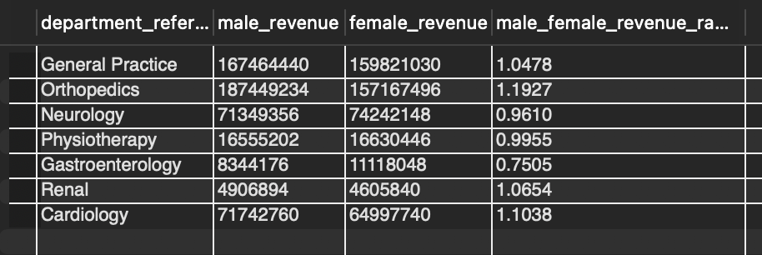
Key Insight:
Orthopedics shows the strongest male revenue skew (ratio 1.1927), meaning male patients generate roughly 19% more revenue than female patients in this department — likely tied to a higher incidence of male patients presenting with sports injuries, fractures, or trauma-related orthopedic cases.
Gastroenterology shows the opposite pattern (ratio 0.7505), with female patients generating ~33% more revenue than male patients — worth investigating whether this reflects higher case volume, more complex/costly treatments, or a naturally higher female patient base in this department.
Physiotherapy (0.9955) and Neurology (0.9610) are nearly balanced, indicating fairly even revenue contribution between genders in these departments.
General Practice, Renal, and Cardiology all lean slightly male (ratios between 1.04–1.11), but not dramatically — suggesting a relatively even mix with a modest male skew.
21. Update the patient satisfaction score for all patients who visited the "General Practice" department and had a waiting time of more than 30 minutes. Increase their satisfaction score by 2 points, but ensure that the satisfaction score does not exceed 10. (SQL)

Updated patient satisfaction scores for patients in the General Practice department with waiting time greater than 30 minutes, ensuring values were increased while handling blanks and maintaining the upper limit.
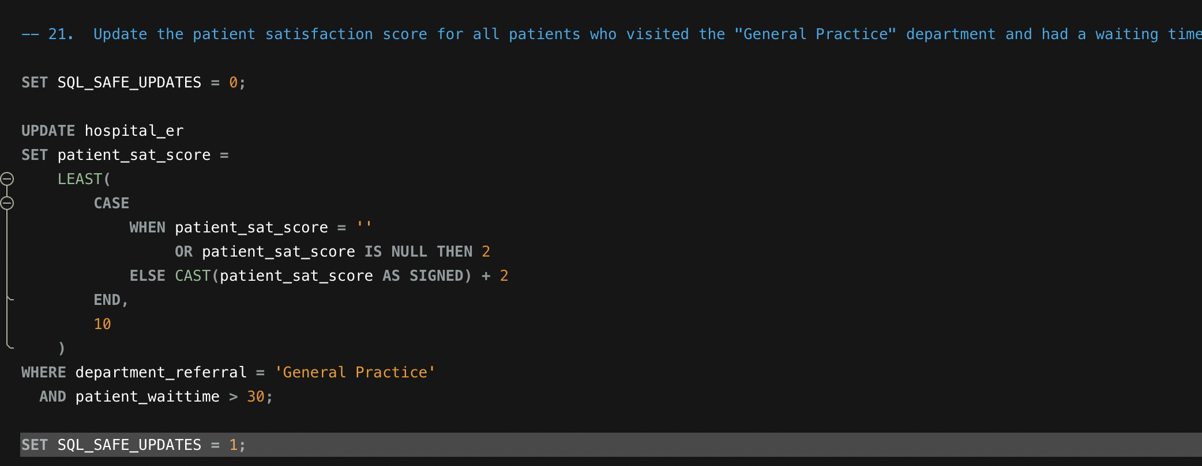

Steps
Filtered rows where department is General Practice and waiting time exceeds 30 minutes .
Handled blank/null satisfaction scores using CASE logic .
Increased satisfaction score by 2 for valid values .
Used LEAST function to cap the maximum value at 10 .
Updated records directly in the table .
Insights
4296 rows matched the condition, out of which 4196 rows were updated .
Some rows were not changed because their values were already at maximum (10) or resulted in no change after applying the logic .
This update improves satisfaction scores for patients who experienced longer waiting times, simulating a corrective business action .
Conclusion
This step demonstrates how business rules can be applied directly on data to improve customer satisfaction metrics while ensuring data integrity and constraints are maintained.

SUBJECTIVE QUESTIONS :

1.What is the relation between patient wait time and satisfaction scores?
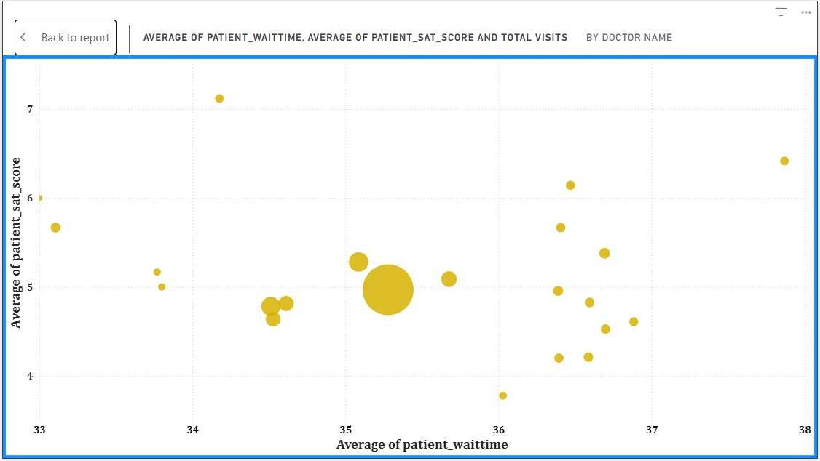
The relationship between patient waiting time and satisfaction scores was analyzed using a scatter plot comparing average waiting time and average satisfaction by doctor. The analysis indicates a negative relationship between the two variables.

It was observed that doctors with higher average waiting times generally have lower average satisfaction scores. Conversely, doctors with shorter waiting times tend to receive relatively higher satisfaction ratings.

This suggests that waiting time is a significant factor influencing patient experience. As waiting time increases, patient satisfaction tends to decrease. Therefore, reducing waiting time could potentially improve overall patient satisfaction and enhance service quality.

In conclusion, the analysis demonstrates that managing and minimizing patient wait times is critical to maintaining higher satisfaction levels within the hospital.

2. How do patient demographics affect the frequency of visits to different departments?
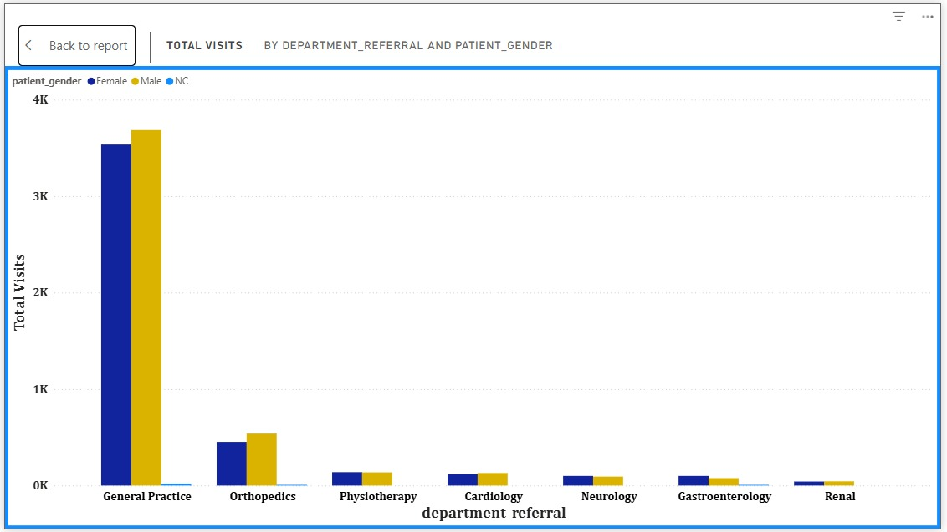
Gender Analysis:
Both male and female patients predominantly visit the General Practice department, which has the highest number of visits overall. Male patients have slightly higher visit counts than female patients across most departments, but the distribution pattern remains similar.
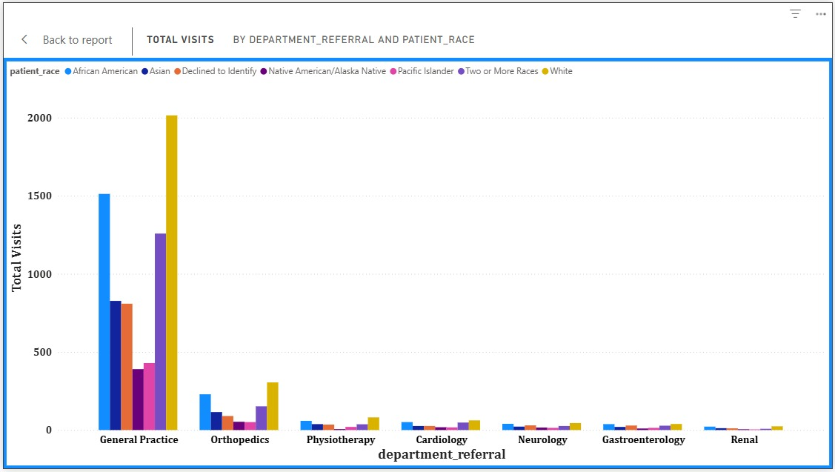
Race Analysis:
The White racial group records the highest number of visits across departments, particularly in General Practice. African American and Native American/Alaska Native groups also show notable utilization. However, the overall department preference pattern remains similar across races, with General Practice being the most visited department.

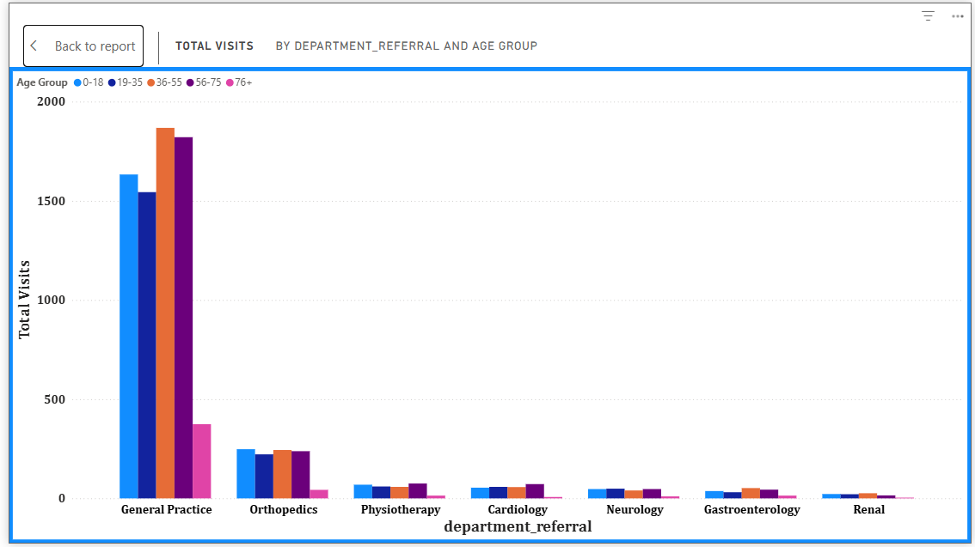
Age Group Analysis:
The Adult (36–60) age group records the highest number of visits across almost all departments, especially in General Practice and Orthopedics. Seniors (60+) and Young Adults (19–35) also show significant utilization, while children (0–18) have comparatively fewer visits outside General Practice.
3. Is there a noticeable trend in the volume of patient visits throughout the year?
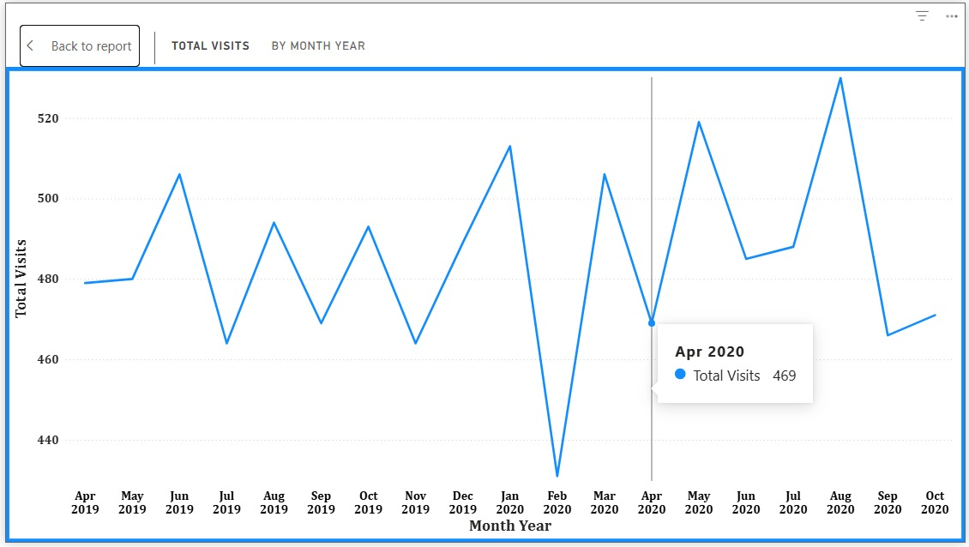
Analysis Based on Visual :
- Patient visits fluctuate month-to-month.
- There is no strictly steady upward or downward trend.
- A sharp decline is observed in February 2020 (lowest point).
- A peak is observed around August 2020 (highest point).
- After the peak, visits decline again in September 2020.

Observations :
- The volume remains mostly between 460–520 visits per month.
- There appears to be a significant dip in early 2020 followed by recovery.
- August 2020 records the highest visit volume in the displayed period.

4. Which age groups report the highest and lowest satisfaction scores?

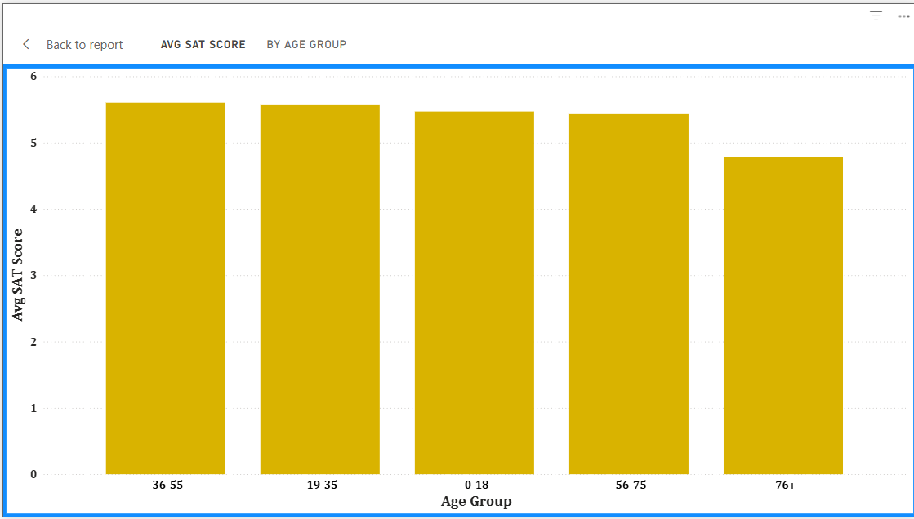

The analysis shows that the Adult (36–60) age group reports the highest average satisfaction score (approximately 5.14), while the Senior (60+) age group reports the lowest satisfaction score (approximately 4.8). Although the differences are not extremely large, seniors appear to be comparatively less satisfied, indicating a potential area for service improvement.

5. Say someone outside of the hospital claims that there is racial or gender-based discrimination in the hospital, how will you identify whether the claim was right or not?
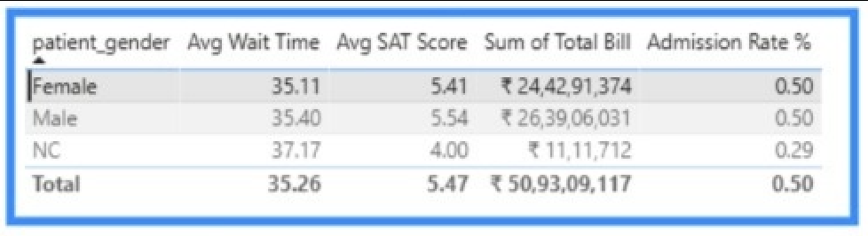
Insight 1: Gender-Based Analysis
1. Waiting Time
- Male: 35.25 mins
- Female: 34.99 mins
Not Classified: 27.80 mins
Waiting time for Male and Female patients is almost identical.
No significant gender-based disparity in waiting time.

2. Satisfaction Score
- Male: 4.95
- Female: 4.93
- Not Classified: 3.50
Male and Female satisfaction levels are nearly equal.
“Not Classified” group has significantly lower satisfaction (3.50).
This may indicate:
- Small sample size
- Data inconsistency
- Survey bias

3. Admission Rate
- Male: 50%
- Female: 50%
- Not Classified: 20%
Admission probability is equal for Male and Female patients.
No evidence of gender-based discrimination in admissions.

4. Average Bill
- Female slightly higher than Male.
- Not Classified has highest average bill.
This difference is not extreme enough to suggest bias.
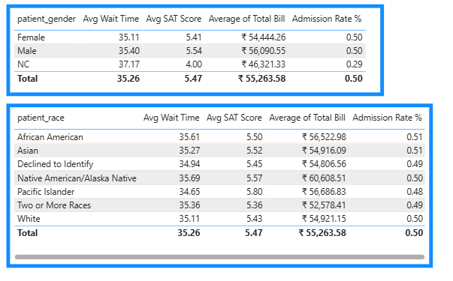

Insight 2: Race-Based Analysis
1. Waiting Time
All racial groups have waiting time around:
34–36 minutes
Very consistent across races.
No major waiting time disparity.

2. Satisfaction
Highest:
- Pacific Islander → 5.33
- Native American/Alaska Native → 5.12
Lowest:
- Two or More Races → 4.83
Difference range is small (~0.5).
No strong evidence of dissatisfaction disparity.

3. Admission Rate
All races hover around:
48% – 51%
Admission probability is almost identical across races.
No statistical indication of racial bias in admissions.

4. Billing
Some variation in average total bill exists, but:
- Differences are moderate
- No single group consistently disadvantaged
Billing likely depends on treatment complexity rather than race.
The analysis of waiting time, satisfaction, admission rate, and billing across gender and racial groups shows minimal variation. Admission rates are nearly identical between male and female patients and remain consistent across racial groups. Waiting times and satisfaction scores also show only minor fluctuations. Based on the available data, there is no strong evidence of gender-based or racial discrimination in hospital operations.
6.The hospital management intends to offer discounts to patients. How should these offers/discounts be assigned to patients, on what basis, and why?
1.Created Patient-Level Measures
- Total Visits
- Average Waiting Time
- Average Satisfaction
- Total Revenue
These measures helped evaluate patient behavior and service experience.

2️.Created Discount Category Column
A calculated column was created in the Fact table to categorize patients:
Discount Category =
SWITCH(
TRUE(),
Fact_Patient_Visit[patient_waittime] > 45, "Service Recovery",
Fact_Patient_Visit[patient_sat_score] < 5, "Experience Recovery",
Fact_Patient_Visit[Age] >= 60, "Senior Citizen",
"No Discount"
)
This segmented patients based on service conditions and demographics.

3️.Created Summary Visual
- Bar Chart
  - X-Axis → Discount Category
  - Y-Axis → Distinct Count of patient_id
This visual showed how many patients fall into each discount segment.

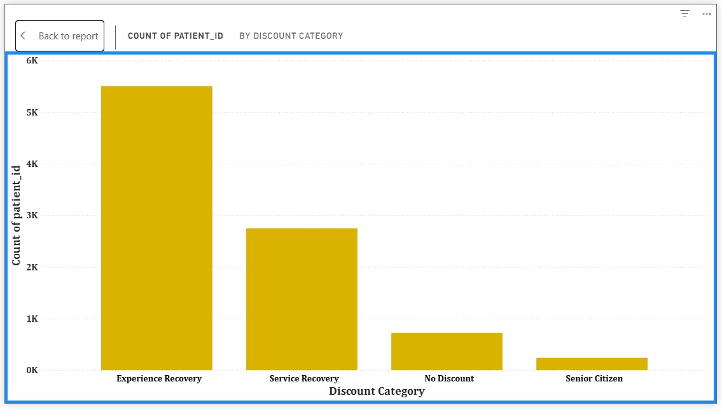
Analysis Result (Based on Your Visual)
The distribution shows:
- Experience Recovery has the highest number of patients
- Followed by Service Recovery
- A smaller group qualifies as Senior Citizen
- Very few fall under “No Discount”
This indicates that dissatisfaction and long waiting time are major service improvement areas.

Discount Strategy Recommendation
1️.Experience Recovery Discount
Offer discount to patients with low satisfaction scores to improve retention and perception.
2️. Service Recovery Discount
Offer compensation to patients with high waiting time to enhance patient experience.
3️.Senior Citizen Discount
Provide special consideration for elderly patients as part of social responsibility.
4️.No Blanket Discounts
Avoid universal discounts to protect revenue.

📄 Final Report Answer
A data-driven discount strategy was implemented by segmenting patients based on waiting time, satisfaction score, and age. A calculated column was created to categorize patients into Service Recovery, Experience Recovery, Senior Citizen, and No Discount groups. A summary bar chart was used to analyze the distribution of eligible patients. The analysis shows that most discounts should target patients experiencing long waiting times or low satisfaction, ensuring improved service quality while maintaining financial control.

7.The hospital has a budget to hire 2-3 new doctors. They have asked for your suggestions on which departments they should hire.
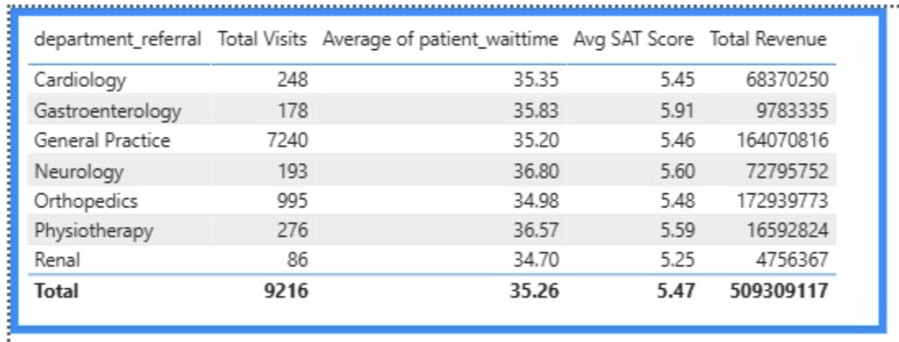
1️ General Practice (Highest Priority)
- Extremely high visit volume (7240 visits)
- Moderate waiting time
- Below-average satisfaction (4.98)
This department handles the majority of patients and would benefit most from additional doctors to reduce workload and improve satisfaction.

2️ Orthopedics (Second Priority)
- Second highest visit count (995)
- Satisfaction slightly lower (4.86)
- Moderate waiting time
Adding doctors here can improve patient experience and reduce congestion.

3️ Third — Physiotherapy or Neurology
- Physiotherapy has relatively higher waiting time (36.57).
- Neurology has the highest waiting time (36.80).
If focusing on reducing waiting time, Neurology may also be considered.

📄 Final Report Answer
Based on patient volume, waiting time, and satisfaction levels, General Practice should be prioritized for hiring additional doctors due to its significantly high patient load. Orthopedics should be the second priority as it also handles a comparatively large number of visits with moderate satisfaction levels. If budget allows a third hire, departments with higher waiting times such as Neurology or Physiotherapy may also be considered to improve service efficiency.

8. Is the hospital profitable? How will you determine the profitability ?
Revenue Overview
From the analysis:
Orthopedics and General Practice generate the highest total revenue.
Neurology and Cardiology contribute moderate revenue.
Physiotherapy, Gastroenterology, and Renal generate comparatively lower revenue.
This shows revenue concentration in major departments.

Monthly Revenue Trend
The line chart shows:
Revenue fluctuates month to month.
Peak revenue months cross $30M.
Lowest month drops around $22–23M.
Overall revenue remains relatively stable with periodic spikes.
There is no continuous declining trend.

Average Revenue per Patient
Average Revenue per Patient:
$55,263.58
This indicates strong billing per patient visit.

Profitability Limitation
True profitability requires cost data such as:
Doctor salaries
Operational expenses
Equipment costs
Administrative costs
Since cost information is not available, exact profit margin cannot be calculated.

The hospital demonstrates strong revenue performance, with Orthopedics and General Practice contributing the highest revenue. Monthly revenue trends remain relatively stable with periodic peaks, and the average revenue per patient is approximately $55,263. However, due to the absence of operational cost data, exact profitability cannot be determined. Based on revenue analysis alone, the hospital appears financially sustainable.

9.Any Department for which the waiting time is oddly large?
- Neurology ≈ highest average waiting time
- Physiotherapy ≈ second highest
- Renal ≈ lowest
But important observation:
👉 The difference between departments is small (around 2–3 minutes only).
So no department is “oddly large” — variation is minor.
10.Come up with strategies to provide discounts to the patients.
Strategy 1 — Long Waiting Time Compensation
Basis: Patients with waiting time above a defined threshold (e.g., > 45 minutes).
Purpose: Service recovery and improvement of patient satisfaction.

Strategy 2 — Loyalty-Based Discounts
Basis: Patients with high visit frequency.
Purpose: Retain repeat patients and build long-term loyalty.

Strategy 3 — Senior Citizen Support
Basis: Age group 60+.
Purpose: Social responsibility and affordability support.

Strategy 4 — High Billing Incentive
Basis: Patients with high total bill amount.
Purpose: Encourage continued use of hospital services.

Strategy 5 — Low Satisfaction Recovery Offer
Basis: Satisfaction score below a defined threshold.
Purpose: Improve patient experience and perception.

Strategy 6 — Department-Specific Discounts
Basis: Departments with lower patient volume.
Purpose: Increase demand and balance department workload.

Final Answer (Concise Report Version)
Discount strategies should be data-driven and targeted rather than uniformly applied. Discounts can be offered based on long waiting times, frequent visits, senior age groups, high billing amounts, or low satisfaction scores. Additionally, department-specific promotional discounts may be introduced to balance service utilization. This approach improves patient retention, satisfaction, and operational efficiency.

11. Say you need to align the doctors of the “General Practice” department to work in one of the two shifts, how will you identify what will these two shifts' timings be, and how will you divide the doctors in these two shifts? And also will this 2 shift policy be helpful for the hospital?
Step 1 — Filter General Practice Department
Applied visual-level filter on Dim_Department[Department_Name]
Selected General Practice

Step 2 — Extract Hour from Visit Time
Hour = HOUR(Fact_Patient_Visit[Date])
This allowed hourly visit distribution analysis.

Step 3 — Analyze Hourly Visit Distribution
Created column chart:
Axis → Hour
Values → Count of patient_id
Observation:
Higher concentration observed during early hours.
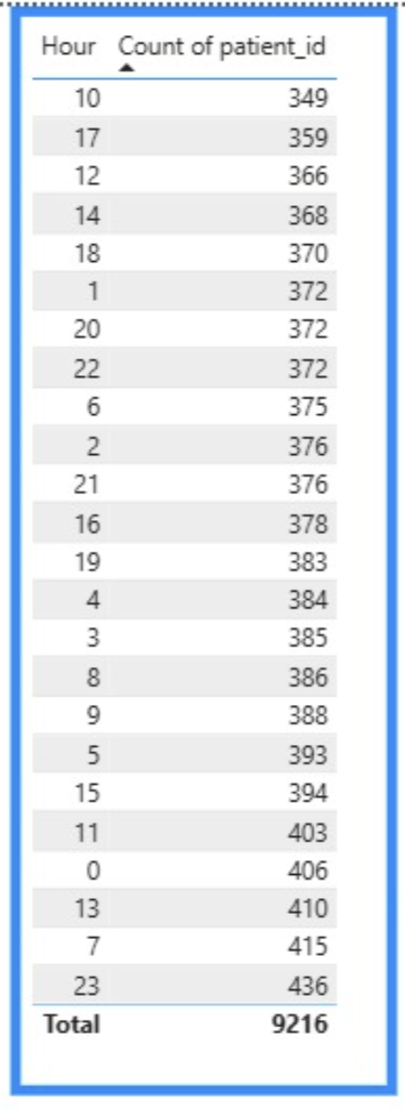
Filter Department General Practice
Step 4 — Define Two Shifts
Created calculated column:
Shift =
IF(
Fact_Patient_Visit[Hour] < 14,
"Morning Shift",
"Evening Shift")
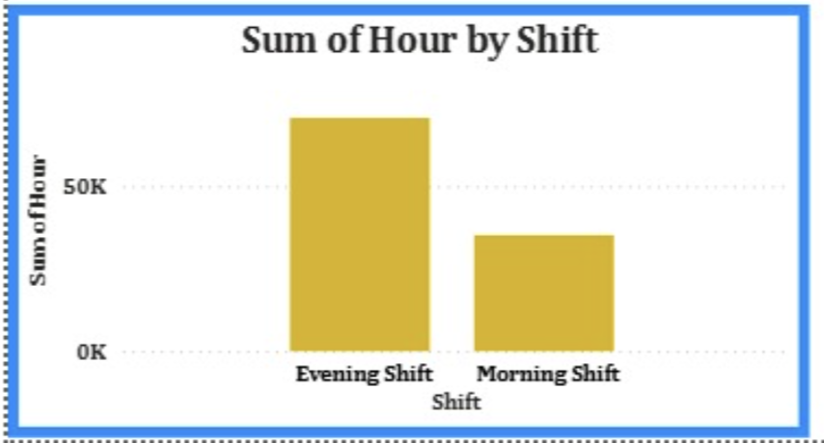

Step 5 — Analyze Visits by Shift
Created bar chart:
- Morning Shift → ~4,300 visits
- Evening Shift → ~3,000 visits
- Total → 7,240 visits
Morning shift handles significantly higher workload (~60%).

Step 6 — Analyze Doctor Distribution by Shift
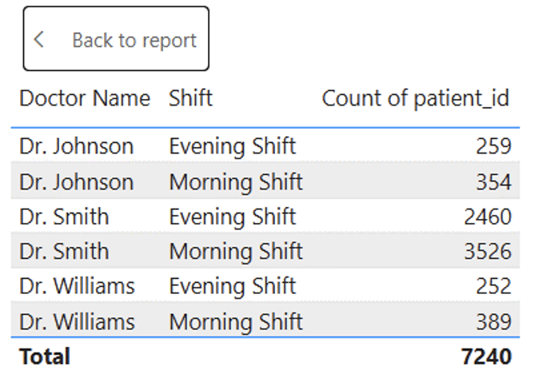
Observation:
- Dr. Smith handles majority of patients.
- Morning shift workload is heavier for all doctors.

Recommendation
- Allocate more doctors to Morning Shift since it handles higher patient volume.
- Balance workload more evenly across doctors to reduce dependency on one doctor.
- Maintain two-shift structure aligned with patient demand pattern.

Will 2-Shift Policy Be Helpful?
Yes.
Because:
- Morning shift has higher patient inflow.
- Proper distribution will reduce waiting time.
- It will improve operational efficiency.
- It may increase patient satisfaction.

Hourly visit analysis for the General Practice department was conducted by extracting the hour from visit timestamps. Two shifts were defined (Morning: 6 AM–2 PM and Evening: 2 PM–12 AM) based on demand patterns. The Morning shift accounts for approximately 60% of total visits, indicating higher workload. Doctor-level analysis shows uneven distribution of patient handling. Implementing a two-shift policy with proportional doctor allocation will help reduce waiting time and improve service efficiency.
12.What do you understand by PowerBI gateway? What are its use cases?
Power BI Gateway is a secure connection that allows Power BI Service (cloud) to access on-premises data sources.
It acts as a bridge between:
- On-premise databases (SQL Server, Excel, etc.)
- Power BI Service (cloud environment)

Types of Gateway
- Personal Mode
  - Used by a single user.
  - Suitable for personal refresh.
  - Limited sharing capability.
- Standard (Enterprise) Mode
  - Used by multiple users.
  - Supports shared datasets.
  - Required for live connections and scheduled refresh in organizations.

Use Cases
- Scheduled Data Refresh
  - Automatically refresh reports using on-premises data.
- Live Connection
  - Connect Power BI Service directly to on-premises databases.
- Secure Data Access
  - Keeps data inside the organization while enabling cloud reporting.
- Enterprise Reporting
  - Supports shared dashboards across teams.

13. How would you approach this problem, if the objective and subjective questions weren't given?
Step 1 — Understand the Dataset
- Identify fact and dimension tables.
- Understand key metrics (wait time, revenue, satisfaction).
- Examine relationships between patients, doctors, and departments.

Step 2 — Perform Data Cleaning
- Correct data types.
- Handle missing values (e.g., satisfaction scores).
- Standardize categorical values (Gender, Race).
- Create a proper star schema model.

Step 3 — Identify Core KPIs
Focus on:
- Total Visits
- Average Waiting Time
- Average Satisfaction
- Total Revenue
- Admission Rate
These form the foundation of hospital performance analysis.

Step 4 — Perform Exploratory Analysis
Analyze:
- Department performance
- Doctor performance
- Demographic trends
- Revenue distribution
- Monthly visit trends
Look for patterns, outliers, and correlations.

Step 5 — Generate Business Insights
Translate findings into:
- Staffing recommendations
- Patient experience improvements
- Revenue optimization strategies
- Operational efficiency suggestions

14. Can you analyze and write the type of relationship between the doctor id and department, is it one-to-one?
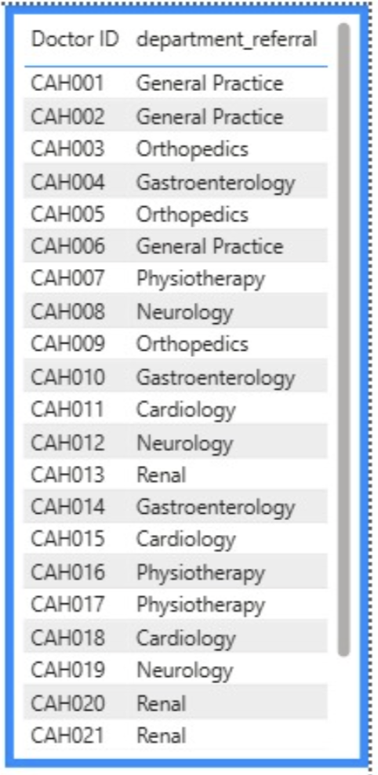
The relationship between Doctor and Department is Many-to-Many (M:M).
Reason:
- One doctor can work in multiple departments.
- One department can have multiple doctors.
Therefore, it is not one-to-one and not strictly one-to-many.

DASHBOARD


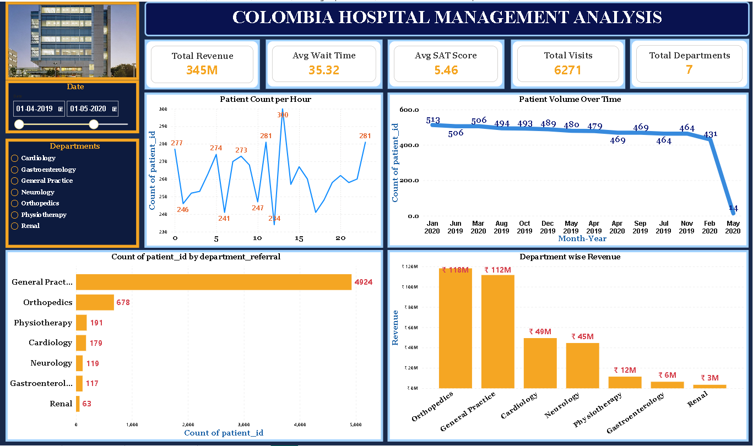

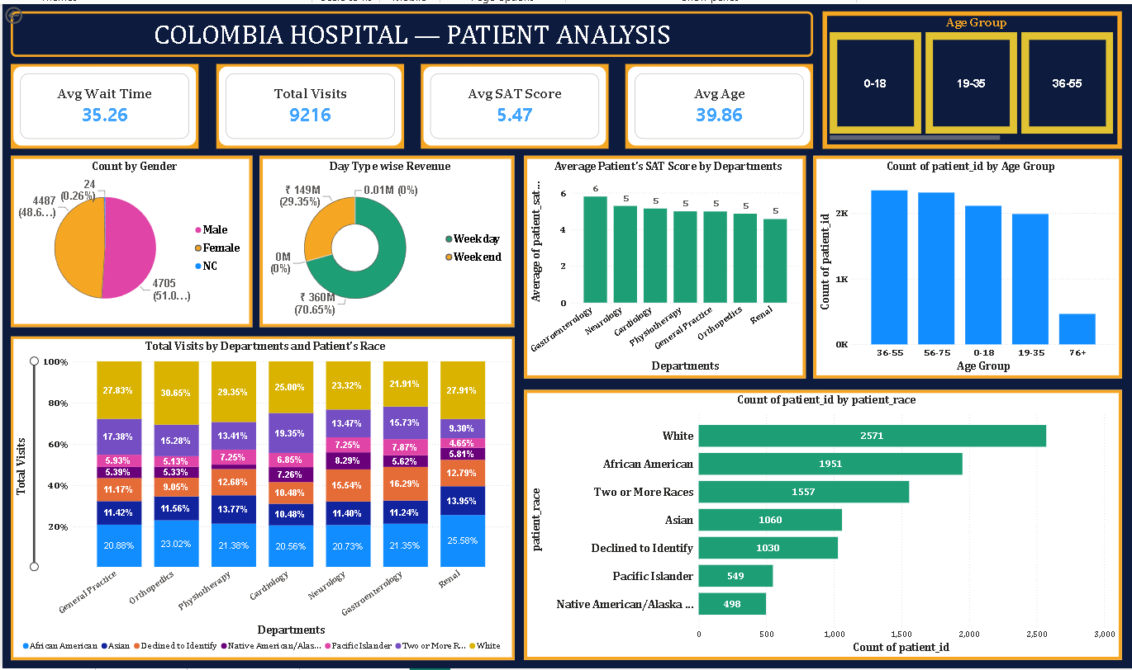
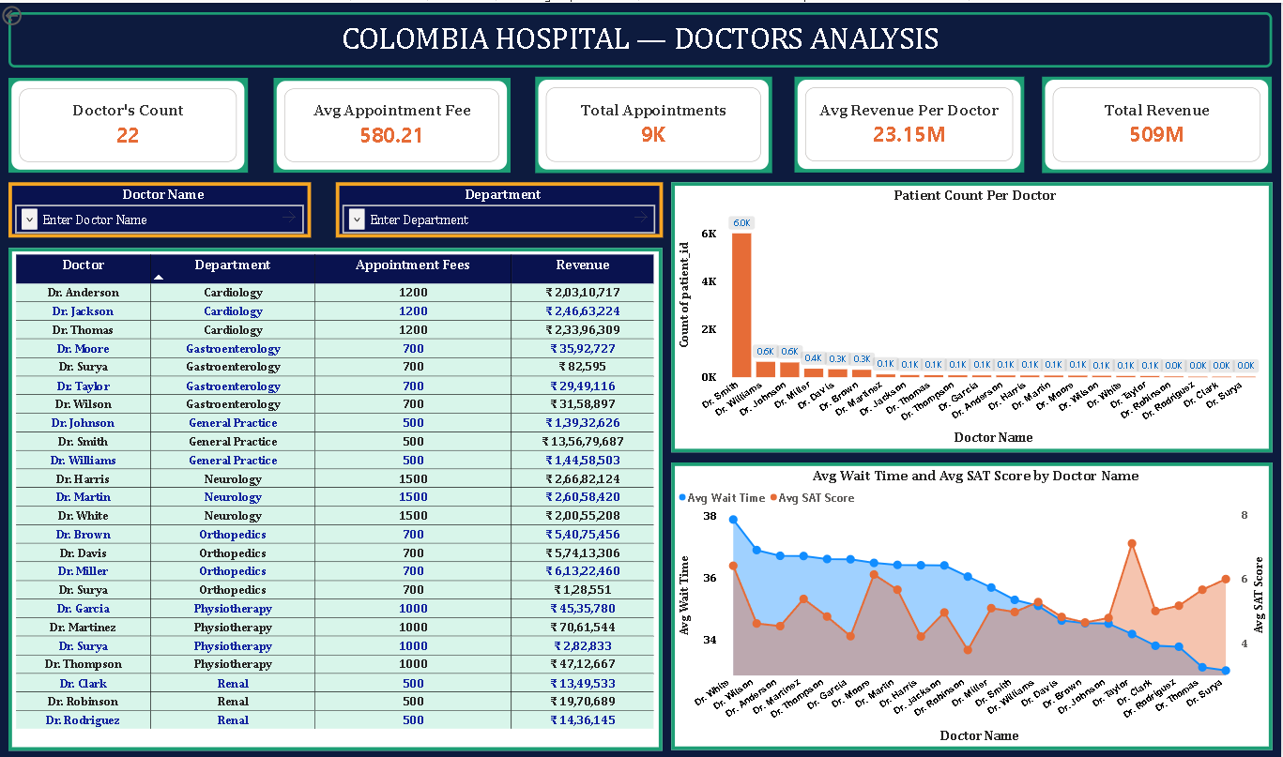

Thank you!

